Appendix A

Pages:

index.html

Sports.html

Activity.html

CSS:

index.css

Scripts:

main.js

The homepage is index.html.

The style index.css applied to all pages

The scripts work for index.html

Appendix B

My page is responsive to all criteria:

Desktop:

iPad (768x1024px):

iPad Landscape (1024x768px):

Responsive to standard iPhone 6/7/8 (375x667px):

Responsive to iPhone 6/7/8 landscape (667x375px):

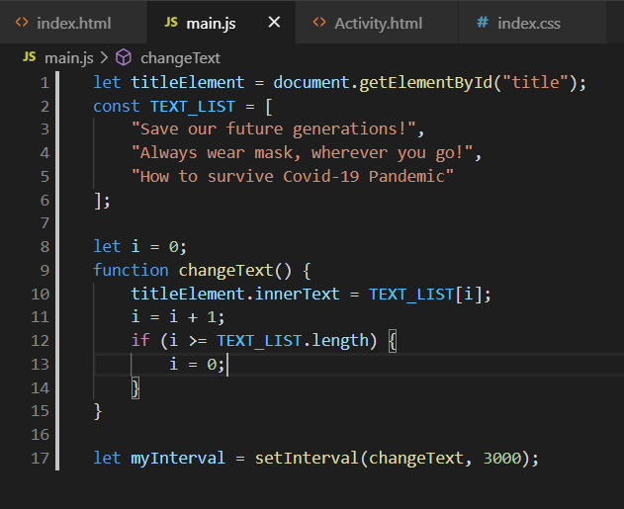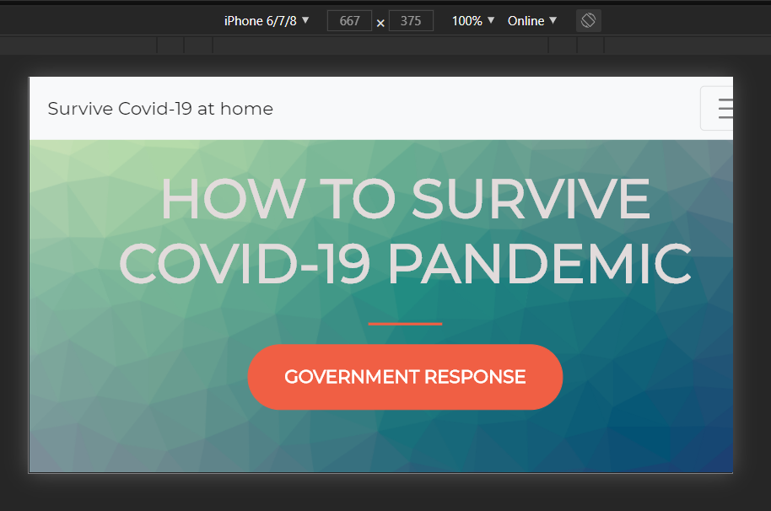The title changed text every 3 secs: